

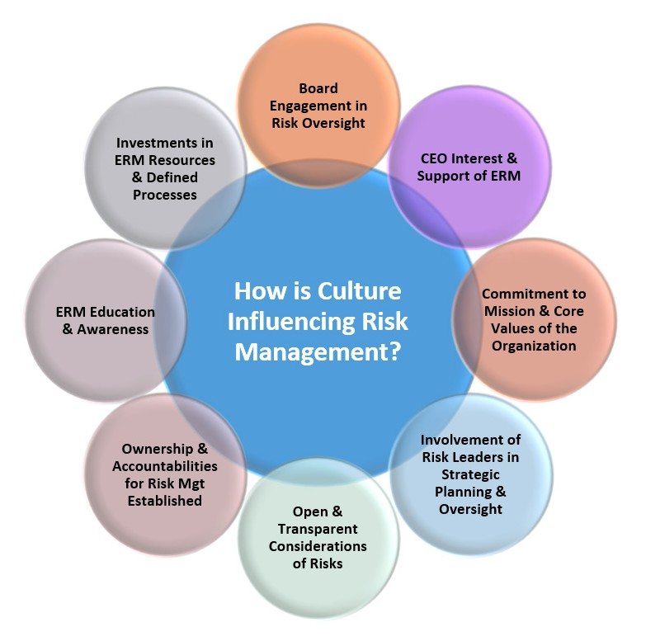
ERM Tool

Assessing How Organizational Culture Impacts Risk Management

BRIEF DESCRIPTION OF TOOL
Each organization has its own unique culture, and there is no one-sized “right culture.” From a risk management lens, it is important for business leaders to consider how their organization’s culture (and potentially different sub-cultures across the enterprise) impact the organization’s risk management efforts. An organization’s culture might influence the amount of risk taking that is occurring across the organization, the willingness for management to engage in risk thinking, and how the entity manages and responds to those risks. Culture can support an effective enterprise-wide approach to risk management (ERM) or it can be one of ERM’s biggest detractors.

HOW TO USE
The diagram below highlights a number of different influencers of an organization’s culture that can impact an organization’s risk management effort. The tool on the next page includes several prompts for management to consider as it attempts to get a read on how the organization’s culture might be affecting – both positively and negatively – the entity’s effectiveness at managing the ever-changing risk landscape facing the business. The tool could be used as a discussion guide with other members of management or perhaps the risk committee to prompt a dialogue about how the organization’s culture is affecting the ERM process. Or, it could be used as an interview script when meeting with an executive individually.

This tool is copyrighted by the ERM Initiative in the Poole College of Management at North Carolina State University (2024).
Questions: contact ERM_Initaitive @ncsu.edu. Visit us at erm.ncsu.edu

Assessing How Organizational Culture Impacts Risk Management
Consider each of the questions below and document your thoughts in the column labeled “responses.”
OVERARCHING QUESTION: | RESPONSES:
How is our organization’s culture influencing our approach to managing risks across the enterprise?
IMPACT OF DIFFERENT CULTURE INFLUENCERS:
BOARD ENGAGEMENT IN RISK OVERSIGHT:
- Is the full board engaged in risk oversight or is that delegated to a subcommittee?
- Are top risks given genuine visibility at the board?
- Is the board asking for risk insights?
CEO INTEREST & SUPPORT OF ERM:
- Does CEO speak about the value of ERM process?
- Is CEO empowering ERM across organization?
- Does the ERM function have to “push” risk information upwards or is CEO “pulling” for more risk insights?
COMMITMENT TO MISSION & CORE VALUES OF ORGANIZATION:
- Do C-suite behaviors support commitment to core values?
- Are there a number of “sub-cultures” across the organization?
- Does organization encourage “silo” or enterprise-wide thinking?
- Is there a commitment to appropriate risk-taking?
INVOLVEMENT OF RISK LEADERS AND STRATEGIC PLANNING & OVERSIGHT:
- Is ERM viewed as a strategic tool for the organization?
- How far down in the organizational chart is the ERM function from the CEO?
- Is the ERM leader a “trusted voice” among senior executives?
- Does the ERM function have sufficient “air time” with senior executives?

IMPACT OF DIFFERENT CULTURE INFLUENCERS:
OPEN & TRANSPARENT CONSIDERATIONS OF RISKS:
- Does the organization’s culture encourage and support the escalation of risk issues to senior executives?
- Do risk messengers feel comfortable sharing risk information to those more senior?
- Is sufficient attention given to risk discussions?
OWNERSHIP & ACCOUNTABILITIES FOR RISK MANAGEMENT ESTABLISHED:
- Are risk owners held accountable for managing risks?
- Are risk limits regularly overridden and ignored?
- Are risk owners asked to update the board about their assigned risks?
ERM EDUCATION AND AWARENESS:
- Is ERM viewed as a project or process?
- Are risk management competencies a component considered in hiring and promotion decisions?
- Are the objectives of ERM clear in the minds of executives across the organization?
INVESTMENTS IN ERM RESOURCES & DEFINED PROCESSES:
- Do we have the right amount and types of personnel to lead the ERM process?
- Is the ERM process adequately resourced?
- Do business leaders give ERM sufficient attention?
OTHER INFLUENCERS:

