

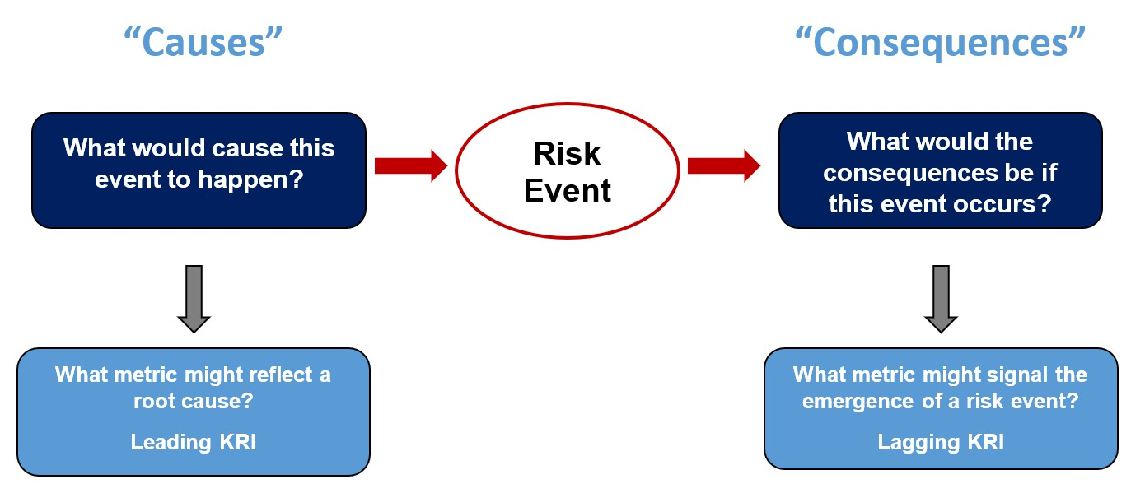
ERM Tool

Using Bow-Tie Analysis
to Develop Key Risk Indicators
BRIEF DESCRIPTION OF TOOL
Many organizations find that the “bow-tie” analysis tool is helpful in guiding business leaders through the design of effective metrics that they can use as key risk indicators to monitor risk trends. The “bow” in the tool is reflected below as the “risk” that is in the center of the diagram, similar to the knot in a bow-tie. This is the risk that is of concern.

HOW TO USE
Pinpointing Metrics to Monitor Risk Root Causes: To the left of the “risk,” the bow-tie prompts business unit leaders to think about metrics that they can use to monitor trends related to root causes that might occur before the actual risk event is realized. Below that, the bow-tie tool prompts business leaders to think about what data or other mea- sures they could use to monitor changes in the root cause. Those metrics would repre- sent “leading key risk indicators.”

Pinpointing Metrics to Monitor an Occurrence of the Risk Event: Not all risks can be identified before they begin to occur. That is, we may not recognize that a root cause has changed until signs of the actual risk event begin to emerge. The right side of the bow-tie analysis prompts business leaders to think of metrics that they can use to recognize the occurrence of a risk as soon as it begins to occur, but before its impact becomes signifi- cant. Those metrics would represent “lagging key risk indicators.”

An example of a completed bow-tie tool is shown on the next page.

This tool is copyrighted by the ERM Initiative in the Poole College of Management at North Carolina State University (2024).
Questions: contact ERM_Initaitive @ncsu.edu. Visit us at erm.ncsu.edu


ERM RESOURCE CENTER
www.erm.ncsu.edu

Using Bow-Tie Analysis to Develop Key Risk Indicators
Example of a completed bow-tie analysis tool to identify metrics that might serve as leading and lagging key risk indicators
Causes | Metrics (Data) Related to Root Cause ( Leading KRIs) |  | Consequences | Metrics (Data) Related to Initial Risk Impact (Lagging KRIs)
Compensation and benefits not  competitive. | Benchmarking data about compensation and benefits from industry. |  | Key operations are interrupted for period of time. | Number of operations delayed or suspended due to inadequate staffing.
 | Complaints about compensation  and benefits from exit interviews. |  |  | Key turnover stats by function/ operations.
Younger talent do not view industry as favorable. | Surveys about most desired industries for recent college graduates or young professionals.  Average age or length of expe- rience of applicants received by our organization. | Risk Concern: Current environment may  make it difficult to attract and retain talented workforce. | Existing employee base has to work overtime. | Percentage of workforce having to work overtime.  Functions that have higher overtime workforce relative to all functions.
Unclear career path options. | Comments received by HR from existing employees in employee surveys and during annual review discussions. |  | Over-taxed workface  continues to leave at faster pace. | Key turnover stats by function/ operations.  Exit interview comments about excessive workload demands.
 | Percentages of positions filled with individuals from outside the organization. |  |  | Frequency of comments or complaints posted on job related social media platforms.
Limited opportunities for remote/hybrid schedule. | Comparison of flexible offerings with competitors, by role and industry. |  | Certain initiatives have to be placed on hold if can’t fill key positions. | Number of delayed initiatives and  projects due to staffing needs.
 | Employee requests from surveys Higher turnover rates by role/ position.

