

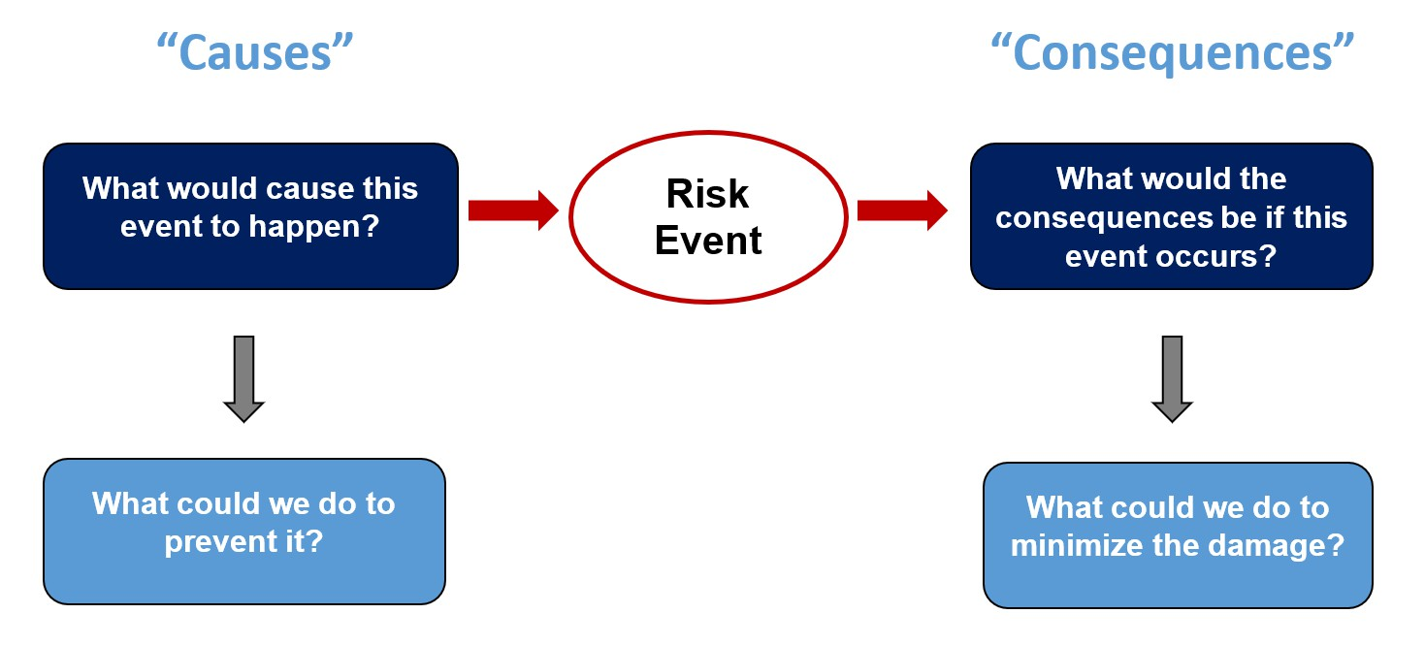
ERM Tool

Using Bow-Tie Analysis to Identify Risk Responses
BRIEF DESCRIPTION OF TOOL
Many organizations find that the “bow-tie” analysis tool is helpful in guiding business leaders through the design and implementation of effective risk responses. The “bow” in the tool is reflected below as the “risk” that is in the center of the diagram, similar to the knot in a bow-tie. This is the risk that is of concern.

HOW TO USE
Pinpointing Preventative Risk Responses: To the left of the “risk,” the bow-tie prompts business unit leaders to think about risk causes that might cause the risk to emerge. Below that, the bow-tie tool prompts business leaders to think about what the entity can do to prevent the root cause from emerging. Those would represent “preventative risk responses.”

Pinpointing Reactive Risk Responses: Not all risks can be prevented, especially when root causes of a risk are outside the entity. But, it is important for business leaders to think about what they can do to minimize the impact of a risk should it begin to occur. The right side of the bow-tie analysis prompts
business leaders to think the consequences to the entity should the risk begin to occur. Below that, the tool prompts business leaders to identify what risk re- sponses they could put in place to treat the risk once it begins to emerge. Those would represent “reactive risk responses.”

An example of a completed bow-tie tool is shown on the next page.

This tool is copyrighted by the ERM Initiative in the Poole College of Management at North Carolina State University (2024).
Questions: contact ERM_Initaitive @ncsu.edu. Visit us at erm.ncsu.edu


ERM RESOURCE CENTER
www.erm.ncsu.edu

Bow-Tie Analysis
Example of a completed bow-tie analysis tool to identify preventative and reactive risk responses.
Causes | Responses to Prevent Risk |  | Consequences | Responses to Minimize Impact
Compensation and benefits  not competitive. | Conduct benchmarking with entities who compete for same talent. |  | Key operations are interrupted for period of time. | Prioritize functions that need staffing most and boost compensation packages to secure longer employment.
Younger talent do not view industry as favorable. | Develop awareness campaign of importance of industry. | Risk Concern: | Existing employee base has to work overtime. | Provide bonus incentives and other rewards to recognize extra efforts.
 |  | Current environment may make it difficult to attract and retain talented workforce.
Unclear career path options. | Develop a leadership development program to layout career path options. |  | Over-taxed workface continues to leave at faster pace. | Seek opportunities to out- source key functions to third parties.
Limited opportunities for remote/hybrid schedule. | Offer hybrid work schedule.  Provide options to live in another location and work remote full time. |  | Certain initiatives have to be placed on hold if can’t fill key positions. | Prioritize initiatives to place on  hold first.

