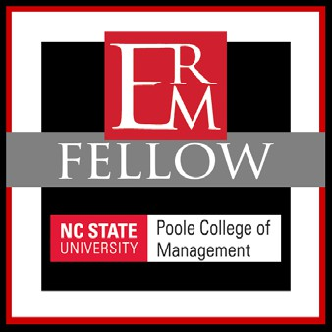
NC STATE UNIVERSITY ERM INITIATIVE

ERM FELLOW DESIGNATION
Last updated December 12, 2019

The ERM Initiative at NC State is excited to offer an opportunity for ERM professionals to achieve an ERM Fellow Designation. Visit https://erm.ncsu.edu/erm-fellow-designation to download the application.
OVERVIEW
The NC State ERM Fellow designation signifies achievement of an exemplary level of executive education in the field of Enterprise Risk Management, a commitment to ongoing education on current practices in ERM, and membership in a network of ERM professionals who will facilitate sharing of best practices and benchmarking of practices within and across industries.

BENEFITS
- Recognition of completion of significant executive education in ERM
- Membership in network of ERM professionals with ongoing opportunities to share and benchmark best practices
- Early access to NC State research, cases, and thought leadership
REQUIREMENTS
Complete 24 CPE credits hours of NC State sponsored events during a 30-month period as follows:

AND
TAKE ONE OF THESE FOUNDATION WORKSHOPS
- The Basics of Launching ERM for Strategic Value
- Evaluating Your Organization’s
Enterprise Risk Management Approach
- Looking Around the Corner: Emerging Risks and ERM Practices
- Any of our ERM Industry specific work- shops (Higher Education, Non-Profits, etc.)

COMPLETE REMAINING HOURS WITH THESE EVENTS
- Roundtable Summit (5 hours)
- Pre or Post Roundtable Workshop (4 hours)
- A second Foundation Workshop (any listed in the box to left) (8-12 hours)
- Other NC State sponsored ERM workshops that may be offered from
time to time
Above courses can be taken in any combination to complete the remaining hours needed.

Complete the application and pay a one-time $50 processing fee.

TAKE ONE TO MAINTAIN NC STATE ERM FELLOW DESIGNATION ANNUALLY
Maintain NC State ERM Fellow Designation. In each calendar year after the year of completion of the initial requirements, ERM Fellows must maintain currency by completing one of the following:
- Roundtable Summit (5 hours)
- Pre or Post Roundtable Workshop (4 hours)
- Any other NC State sponsored ERM workshops that offer at least 4 hours of CPE credit. (NOTE: If a workshop exceeds the 4 hours of CPE credit, the additional hours CANNOT be rolled forward to future years. To maintain the ERM Fellow Designation, individuals must attend at least one workshop in each calendar year.)
2801 Founders Drive | Campus Box 8113
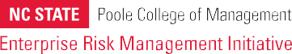
Raleigh, NC 27695-8113
erm_initiative@ncsu.edu
919-513-0901 (PH) | 919-515-4446 (FAX)
www.erm.ncsu.edu

NC STATE UNIVERSITY ERM INITIATIVE

ERM FELLOW DESIGNATION APPLICATION

 | Application Date
FIRST | MI | LAST
JOB TITLE | ORGANIZATION
 | ADDRESS
CITY | STATE | ZIP
PHONE | FAX | EMAIL

Please list the ERM Workshops you have attended with dates below. All workshops will be verified. You will be contacted if you meet the requirements of the ERM Fellow Program. A one-time $50 processing fee will be required upon approval. Please submit completed forms to erm_initiative@ncsu.edu and include ERM Fellow Designation Application in the subject line. You may also fax forms to 919-515-4446 or mail to the ERM Initiative at address listed below. For more information visit https://erm. ncsu.edu/erm-fellow-designation.

ERM Workshop | DATE | FOR INTERNAL USE ONLY

DATE APPROVED

For Internal Use Only

2801 Founders Drive | Campus Box 8113
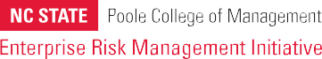
Raleigh, NC 27695-8113 erm_initiative@ncsu.edu
919-513-0901 (PH) | 919-515-4446 (FAX)
www.erm.ncsu.edu

