
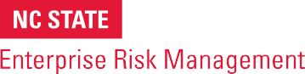
ERM Tool

Using SWOT Analysis to Identify Potential Risks
BRIEF DESCRIPTION OF TOOL
One tool that can be helpful in fostering robust conversations about emerging risks is a SWOT Analysis, which provides a framework for considering both risk threats and risk opportunities linked to an organization’s strengths, weaknesses, opportunities and threats.

Considering “Strengths” and “Weaknesses” often help leaders think about internal risks to the business, given they focus on what the organization does well and where there are potential vulnerabilities.

Considering “Opportunities” and “Threats” often helps leaders think about risks external to the business, given they focus on conditions in the overall business environment that might create strategic advantages or disadvantages for the organization.

HOW TO USE
This template can serve as a discussion guide in a risk workshop with an organization’s key leaders. It might help to share the template with leaders in advance of the meeting to have them think in advance about issues that might be relevant for discussion.

This tool is copyrighted by the ERM Initiative in the Poole College of Management at North Carolina State University (2024).
Questions: contact ERM_Initaitive @ncsu.edu. Visit us at erm.ncsu.edu

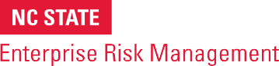
ERM RESOURCE CENTER
www.erm.ncsu.edu

SWOT Analysis Template
STRENGTHS | WEAKNESSES
What do we do well?  What internal resources do we have?  What advantages do we have over similar organizations? | What factors in our control detract from our ability to be more effective?  What areas need improvement? What does our organization lack?
OPPORTUNITIES | THREATS
What opportunities exist in our area of expertise that we can benefit from?  Is the opportunity sustainable or one-time? | What might threaten our effectiveness?  What factors exist that are beyond our control? Are there any anticipated unfavorable trends?

