  - ERM Professional Insights

What is Enterprise Risk Management?
By Mark Beasley
Alan T. Dickson Distinguished Professor of Accounting and Director of the ERM Initiative
NC State University Poole College of Management

Strengthen Organizational Resilience by Embracing ERM
The accelerating pace of change in today’s global environment is generating a surge of complex, interconnected risks that threaten an organization’s ability to achieve its strategic objectives. Geopolitical shifts, disruptive technologies, evolving societal expectations, economic volatility, and aggressive competitive moves are just a few examples of the dynamic forces reshaping the risk landscape. These risks are no longer isolated—they are interwoven in ways that can obscure opportunities and trigger cascading consequences. Forward-thinking leaders are turning to enterprise risk management (ERM) to gain a clearer, enterprise-wide view of risks on the horizon.

This paper explores how ERM enhances traditional risk management practices and demonstrates how a strategically focused risk approach can become a powerful tool for protecting value, enabling agility, and strengthening competitive advantage.

What is Enterprise Risk Management?
Mark S. Beasley
Alan T. Dickson Distinguished Professor of Accounting and Director of the ERM Initiative

Organizations routinely engage in a wide range of risk management activities—monitoring legal and regulatory exposures, safeguarding IT systems from cyber threats, ensuring quality control in operations, purchasing insurance, and maintaining strong financial reporting processes. Because these practices are embedded in day-to-day operations, many business leaders view risk management as simply part of running the business. That perspective often leads to a fair question: Why do we need enterprise risk management (ERM)?

This paper addresses that question by exploring how ERM goes beyond traditional risk silos to provide a strategic,
enterprise-wide lens that helps leaders anticipate, prioritize, and respond to risks that could shape the organization’s future.

Rethinking Traditional Risk Management
For decades, business leaders have managed risks as part of their daily responsibilities. So, when the concept of enterprise risk management (ERM) is introduced, it’s not a critique of existing practices. Rather, it’s an invitation to think differently about how risks are managed across the enterprise.
Traditionally, risk oversight is delegated to functional leaders who manage risks within their specific domains. The Chief Technology Officer focuses on IT-related risks, the Treasurer monitors financial exposures, the Chief Operating Officer oversees operational risks, and the Chief Marketing Officer manages customer and market-related risks. Each leader is responsible for identifying and responding to risks within their silo, as illustrated in Figure 1.
Traditional risk management is essential—but incomplete.
Figure 1: Traditional Siloed Approach to Risk Management

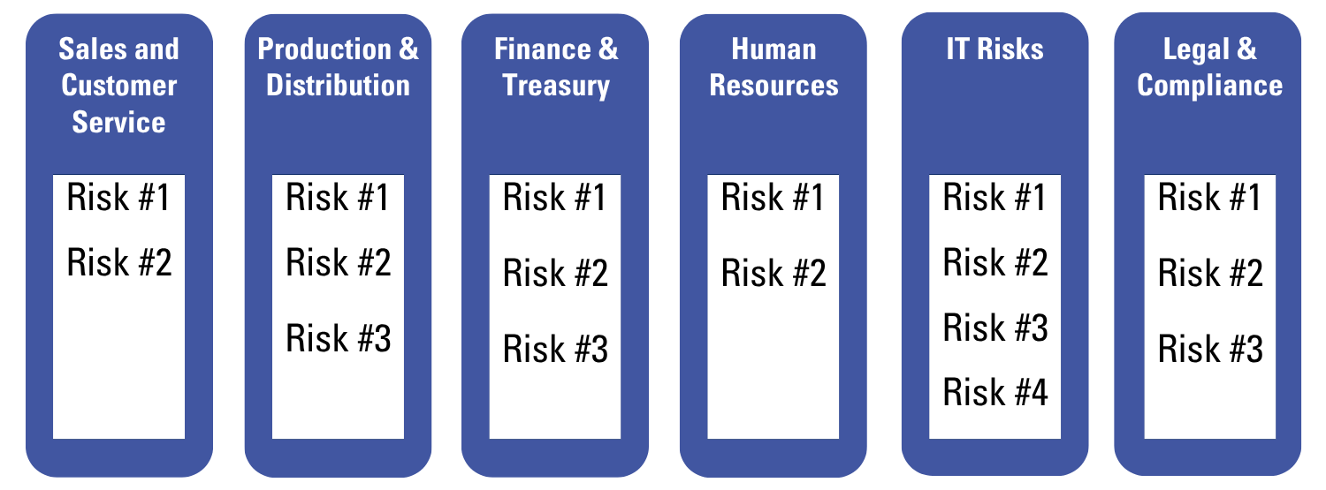
This siloed approach—often referred to as “stove-pipe” risk management—makes sense on the surface. It leverages subject matter expertise and aligns risk ownership with operational accountability. However, it also creates blind spots. Risks that span multiple functions or fall outside traditional boundaries may go unnoticed, and silo-specific responses can unintentionally create new risks elsewhere in the organization.

Limitations with Traditional Approaches to Risk Management
While assigning functional subject matter experts responsibility for managing risks related to their business unit makes good sense, this traditional approach to risk management has limitations. That means there may be significant risks on the horizon that may go undetected by management and that might affect the organization. Let’s explore a few those limitations.
Siloed risk management creates blind spots.
Limitations | Traditional Approaches to Risk Management
Limitation #1:  Risks Fall Between Silos | Risks don’t follow organizational charts. A risk may go unnoticed if no silo leader sees it.  Example:  Individual functional leaders may not be paying attention to fast changing demographic shifts toward urban  centers, leading a retail chain to invest in declining suburban areas.
Limitation #2:  Risks Affect  Multiple Silos | A risk may seem minor in one area of the business but have major implications elsewhere.  Example:  A compliance leader may overlook changes in Brazilian regulations, unaware that strategic plans for customer growth and production investments involve expansion into South America.
Limitation #3:  Silo Responses  Create New  Risks | A well-intended response in one silo may trigger unintended consequences elsewhere.  Example:  IT tightens security protocols, frustrating employees and customers, which leads to risky workarounds or  customer attrition.
Limitation #4:  Internal Focus Misses External Threats | Traditional risk management often looks inward at existing operations and processes that are known, while  not paying enough attention to issues emerging external to the organization.  Example:  A competitor’s breakthrough technology goes unnoticed, threatening product relevance.
Limitation #5:  Weak Link to  Strategy | Risk management is often disconnected from strategic planning.  Example:  New initiatives are launched without sufficient input from risk leaders, overlooking critical exposures that  derail strategies.

What’s the impact of these limitations? There can be a wide array of risks on the horizon that management’s traditional approach to risk management fails to see, as illustrated by Figure 2.

Unfortunately, some organizations fail to recognize these limitations in their approach to risk management before it is too late.
Strategy without Risk Insight is vulnerable.

Figure 2 – Currently Unknown, But Knowable Risks Overlooked by Traditional Risk Management
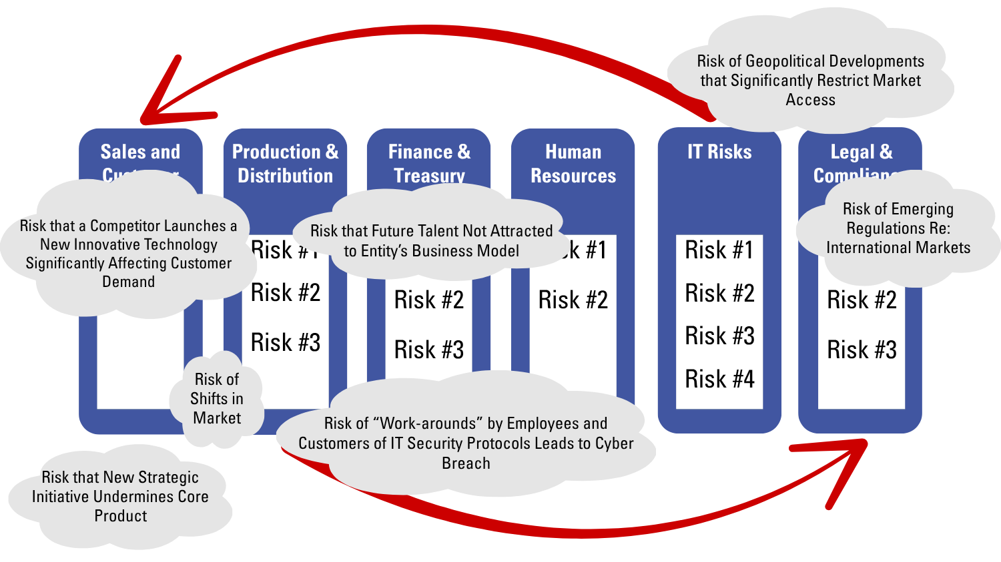

In today’s dynamic and complex environment, forward-thinking business leaders are recognizing these limitations of traditional, siloed approaches to risk management. These reactive models often fail to anticipate risks until they materialize—when it may be too late to respond effectively—and they fail to integrate their risk management and strategic decision-making processes, as illustrated by Figure 3, leading to missed opportunities and wasted resources.

Figure 3 – Currently Unknown, But Knowable Risks
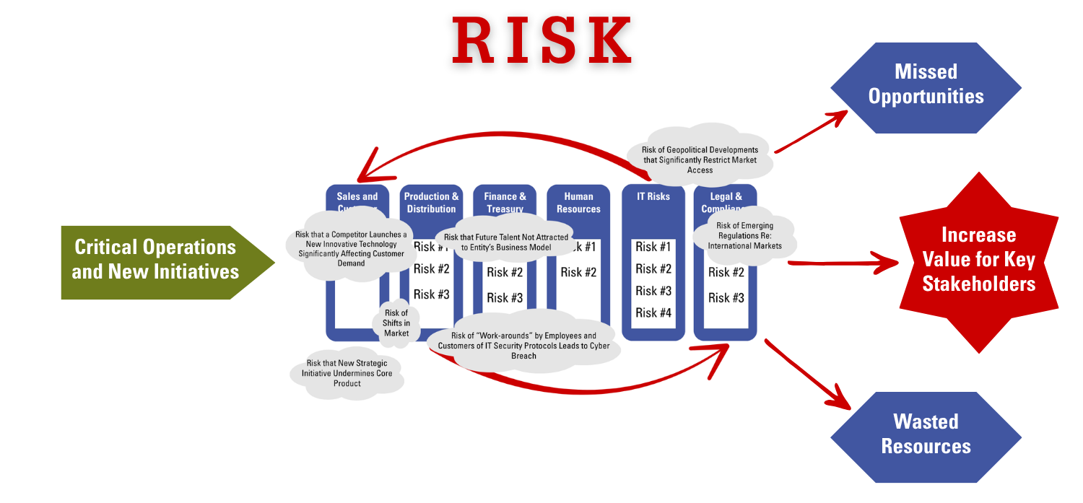

Enterprise Risk Management: A Strategic Imperative for Leadership
At its core, ERM provides a holistic, portfolio-level view of the most significant risks that could impact the achievement of strategic objectives. The “enterprise” in ERM emphasizes a top-down perspective—one that transcends departmental boundaries to capture a comprehensive picture of risk across the organization. This includes both threats and opportunities that could influence the entity’s long-term viability and success.
ERM is not just about avoiding threats – it is about enabling agility.
When implemented effectively, ERM becomes a strategic asset. Risk insights generated through ERM should inform and shape the organization’s strategic planning and decision-making. By understanding emerging risks and their potential impact, executives and boards can craft strategies that are agile, adaptive, and resilient. This proactive approach not only reduces the likelihood of disruptive surprises but also enhances the organization’s ability to respond swiftly and effectively when risks do arise—ultimately creating a competitive advantage.

Enterprise risk management (ERM) offers a proactive, integrated framework that strengthens risk oversight and enhances organizational resilience. By embedding ERM into core business processes, leaders are better positioned to anticipate, assess, and address risks before they escalate.

As illustrated by Figure 4, the ERM process should inform management proactively about risks on the horizon before they occur. That advanced awareness of potential risks can then be incorporated into strategic decision making, which enhances the organization’s agility and nimbleness to keep critical operations and key strategic initiatives on track. Because ERM is not fool-proof, unanticipated risks will continue to emerge, but hopefully the impact leads to smaller missed opportunities and fewer wasted resources relative to what would be realized if the organization is blindsided by higher volumes of unknown risks.
Figure 4 – ERM Should Inform Strategic-Decision Making Before Risks Emerge

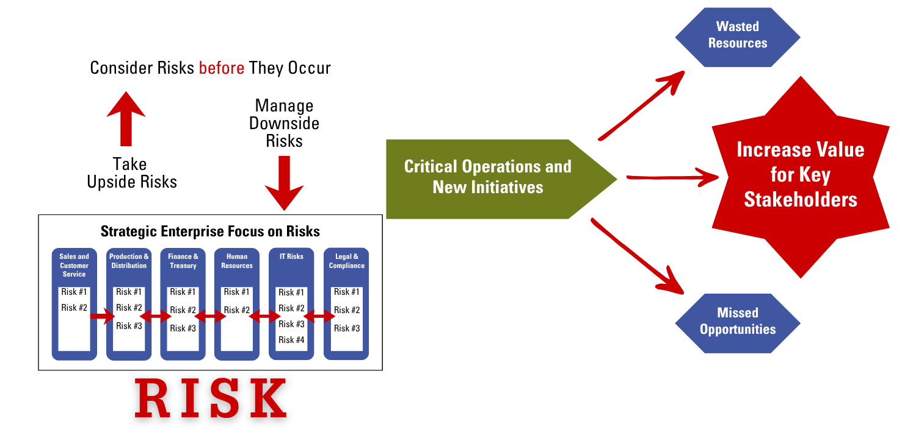

Elements of an Enterprise Risk Management (ERM) Process
ERM is not a one-time project—it is a continuous, evolving process that helps organizations anticipate and navigate risks that could impact their ability to achieve strategic objectives. While the initial implementation of ERM may involve project management disciplines, the real value of ERM emerges when it becomes embedded in the organization’s ongoing management and decision-making processes.
Figure 5 illustrates the core elements of an ERM process. The circular, clockwise flow of the diagram is intentional—it reflects the dynamic and iterative nature of ERM. Once launched, ERM becomes a continuous cycle of identifying, assessing, responding to, and monitoring risks that could affect the organization’s ability to deliver on its mission and strategy.

Figure 5 – Elements of an ERM Process

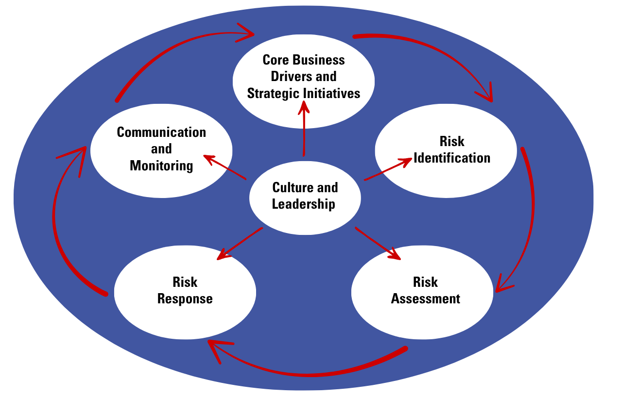

ERM Begins with What Drives Value
A strategically integrated ERM process starts by focusing on what matters most: the drivers of value for the organization. This includes both current sources of value and future value creation initiatives outlined in the strategic plan.

For example, in a publicly traded company, a central objective is to grow shareholder value. ERM should begin by identifying the key elements that currently drive that value—such as unique core products, high-touch customer service, and competitive supply chain advantages. These are often referred to as the organization’s “crown jewels.”

At the same time, ERM must also consider the organization’s strategic initiatives aimed at future growth—such as launching new products, pursuing acquisitions, or investing in more online services. These initiatives represent emerging value drivers that are often accompanied by heightened uncertainty and risk.

By grounding the ERM process in a deep understanding of both current and future value drivers, management is better positioned to identify and assess risks that could threaten or enable the achievement of strategic goals. This strategic lens ensures that ERM remains focused on the risks that matter most to the organization’s long-term success. Having this strategic lens, management can then consider how risks might emerge that impact a “crown jewel” or impede the successful launch of a new strategic initiative, as illustrated in Figure 6.
ERM builds upon a strategic lens to pinpoint risks.
Figure 6 – Apply Strategic Lens to Identify Risks

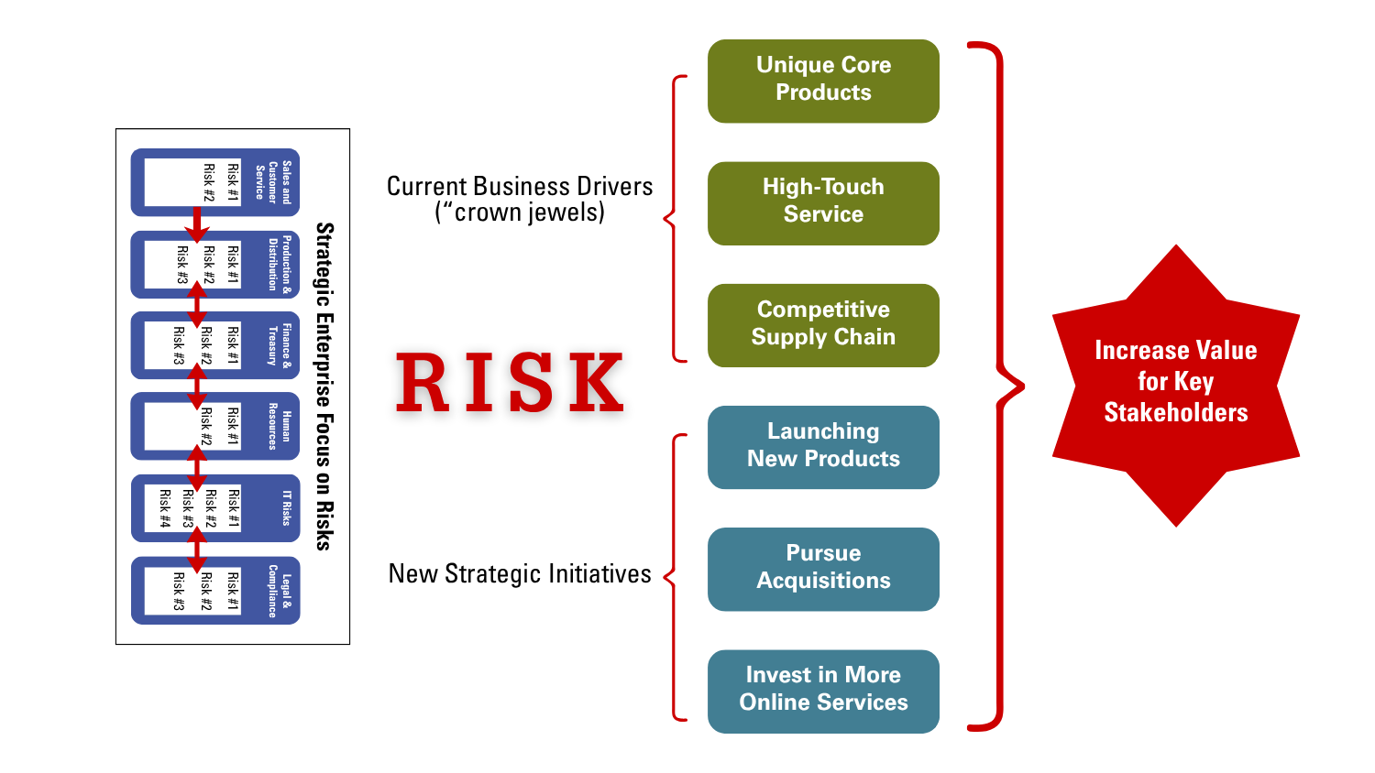

ERM Considers All Types of Risk
While ERM often begins with a focus on risks to the organization’s core value drivers and strategic initiatives, it is not limited to “strategic risks” alone. A well-designed ERM process considers all types of risks—including operational, compliance, financial reporting, reputational, and emerging risks—that could impact the organization’s ability to achieve its objectives.
ERM focuses on the interrelated nature of all kinds of risks, given risks
do not emerge in isolation.
Using a strategic lens simply helps ensure that risk identification is aligned with what matters most to the enterprise. This approach encourages management to think broadly and holistically about risks across the organization, breaking down silos and fostering a more integrated view of risk. When ERM is embedded in this way, it becomes a powerful tool for aligning risk oversight with strategic leadership.

The Output of an ERM Process
The primary output of an ERM process is a clear understanding of the most significant risks facing the organization—those that management collectively believes could most impact the achievement of strategic goals. Many organizations focus on identifying and prioritizing their top 10 enterprise risks, though the number may vary.

These top risks are typically presented to the board in the form of key risk themes, with more detailed analysis and monitoring handled by management. For instance, a top risk theme might be “talent attraction and retention.” While the board may discuss that at a strategic level, management would address specific talent challenges in areas such as IT, sales, or operations.

Once the top risks are identified, management evaluates whether current risk responses are adequate. In some cases, leadership may choose to accept a risk; in others, they may decide to mitigate, transfer, or avoid it. Importantly, risk response planning should address both:

- Preventive actions to reduce the likelihood of a risk occurring, and
- Mitigating actions to reduce the impact if the risk does occur.

A helpful tool for visualizing this dual approach is the Bow-Tie Analysis, illustrated in Figure 7. The “knot” of the bow tie represents the risk event. The left side focuses on actions to prevent the event, while the right side highlights actions to minimize its consequences. (See our article, The Bow-Tie Analysis: A Multipurpose ERM Tool, for more detail.)

Figure 7 – Bow-Tie Tool for Developing Responses to Risks

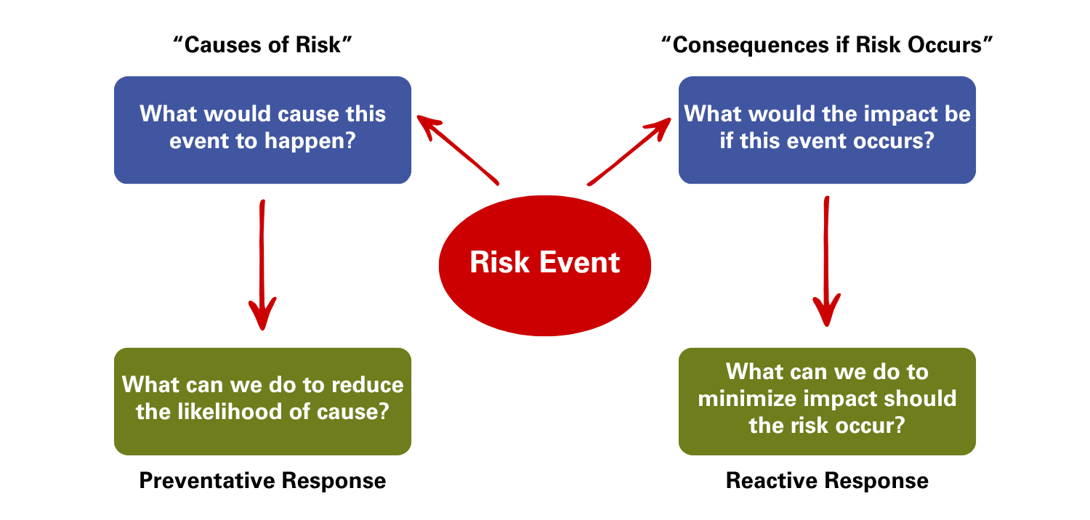

Monitoring and Communicating Top Risks with Key Risk Indicators (KRIs)
While identifying and prioritizing the organization’s most critical risks is a central output of the ERM process, ongoing monitoring of those risks is equally essential. To support this, many organizations are enhancing their management dashboards with Key Risk Indicators (KRIs)—quantitative or qualitative metrics linked to each top risk.

Key Risk Indicators (KRIs) provide early warning signals and support timely decision- making.
KRIs provide early warning signals and help leadership track how risk exposures are evolving over time. By integrating KRIs into regular reporting, management and the board gain greater visibility into risk trends, enabling more informed and timely decisions. This proactive monitoring reinforces ERM’s role as a strategic management tool, not just a compliance exercise.

Leadership and Oversight of ERM
Effective ERM requires strong leadership from executive management and active oversight by the board of directors. Because ERM is designed to provide an enterprise-wide view of risk, it must be led from the top. Senior executives are uniquely positioned to understand the organization’s strategic priorities and risk landscape, and they are ultimately accountable for ensuring risks are appropriately managed.

Management is responsible for designing, implementing, and sustaining the ERM process. This includes determining how the process operates, ensuring it remains dynamic and relevant, and embedding it into strategic planning and operational decision-making.

The board’s role is to provide risk oversight by:
- Understanding and approving the ERM framework and process, and
- Monitoring the organization’s top risks to ensure management’s risk-taking aligns with the enterprise’s risk appetite and stakeholder expectations.

This shared responsibility between management and the board ensures that ERM is not only operationally effective but also strategically aligned with the organization’s long-term goals.

Conclusion
In today’s fast-paced and increasingly complex global environment, the volume and velocity of risks facing organizations continue to grow. At the same time, expectations for more effective risk oversight from boards and senior leadership are intensifying. These realities underscore the need for organizations to critically evaluate whether their current risk management approach is sufficiently proactive and strategically aligned.

Enterprise Risk Management (ERM) is emerging as a leading framework for achieving this elevated level of risk oversight. By providing a structured, enterprise-wide view of risks—anchored in the organization’s strategic priorities—ERM enables leadership to anticipate, assess, and respond to risks in a way that supports long-term value creation. For organizations seeking to strengthen resilience and agility, ERM offers a powerful tool for integrating risk thinking into strategic decision-making at all levels. The content below summarizes the key concepts for effective ERM and outlines calls to action.

Enterprise Risk Management (ERM) Overview

Why ERM Matters | Key Elements of an ERM Process | Leadership & Oversight | Call to Action
- The pace and complexity of risk are accelerating.  - Stakeholder expectations for risk oversight are rising.  - ERM provides a proactive, strategic approach to managing risk. | - Strategic Focus: Begins with understanding what drives value—today and in the future.  - Comprehensive Risk View: Includes strategic, operational, compliance, and reporting risks.  - Prioritization: Identifies top risks that could impact strategic success.  - Monitoring: Uses Key Risk Indicators (KRIs) to track risk trends over time.  - Response Planning: Evaluates current risk responses and identifies gaps | - Executive Management: Designs and sustains the ERM process.  - Board of Directors: Oversees risk strategy and ensures alignment with risk appetite. | - Is our current risk management approach proactive enough?  - Are we integrating risk thinking into strategic decisions?  - How are we using ERM to strengthen resilience and long-term value creation?

Interested in Learning More About ERM?
As business leaders realize the objectives of ERM and seek to enhance their risk management processes to achieve these objectives, they seek additional information about tactical approaches for effectively doing so in a cost-effective manner. The ERM Initiative in the Poole College of Management at North Carolina State University may be a helpful resource through the articles, thought papers, and other resources available on its website in the ERM Resources Center or through its ERM Roundtable and Executive Education offerings.
Visit the ERM Initiative website to learn more.

About the Author
Mark S. Beasley
Alan T. Dickson Distinguished Professor and Director of the ERM Initiative
NC State University Poole College of Management

Mark S. Beasley, CPA, Ph.D., is the Professor of Enterprise Risk Management and Director of the ERM Initiative at NC State University. He completed over seven years of service as a board member of the Committee of Sponsoring Organizations of the Treadway Commission (COSO) and has served on other national-level task forces related to risk management issues. He advises boards and senior executive teams on risk governance issues, is a frequent speaker at national and international levels, and has published over 90 articles, research monographs, books, and other thought-related publications.

