
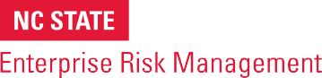
ERM Tool

Using PESTLE Analysis to Identify Potential External Risks

BRIEF DESCRIPTION OF TOOL
While risks can emerge internally from within the operations of the organization, some of the most significant risks are triggered by events external to the organization. Often it’s the external risks that are least managed, given the root causes of those risks are outside the organization’s control.

One tool that can be helpful in fostering robust conversations about emerging risks is a PESTLE Analysis, which provides a framework for considering risks that may be triggered by political, economic, social, technological, legal, and environmental factors.

HOW TO USE
This template can serve as a discussion guide in a risk workshop with an organization’s key leaders. The tool prompts consideration of how external political, economic, social, technological, legal or environmental factors might be emerging that may impact the organization’s business model and strategic objectives. It might help to share the template with leaders in advance of the meeting to have them think in advance about issues that might be relevant for discussion.

This tool is copyrighted by the ERM Initiative in the Poole College of Management at North Carolina State University (2024).
Questions: contact ERM_Initaitive @ncsu.edu. Visit us at erm.ncsu.edu

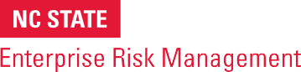
ERM RESOURCE CENTER
www.erm.ncsu.edu

PESTLE Analysis Template
COMPONENT | RELEVANT ISSUES AND AFFECTS
POLITICAL FACTORS
How might elections/change of government leadership, geopolitical forces, potential policy changes, rule of law, etc., affect our organization?
ECONOMIC FACTORS
How might shifts in economic growth or stagnation, interest rates, exchange rates, inflation, unemployment, etc., affect our organization?
SOCIAL FACTORS
How might population and demographic changes, health conditions, level of education, social mobility, social attitudes, religious beliefs, socio-cultural changes, etc., affect our organization?
TECHNOLOGICAL FACTORS
How might changes in the availability or price of new technologies, technological infrastructure, potential changes in technological standards, etc., affect our organization?
LEGAL FACTORS
How might changes in labor laws, relevant court cases, employment regu-lations, etc., affect our organization?
ENVIRONMENTAL FACTORS
How might shifts in climate, weather, energy consumption regulations, etc., affect our organization?

