
A LOOK INTO THE FUTURE WITH SCENARIO PLANNING:
A SURVEY OF ERM PRACTICES

Prepared by Kiersten Woodring, Carson Chrismon, Justin Yim, Danny O’Dirling
NC STATE GRADUATE STUDENTS | POOLE COLLEGE MANAGEMENT
FACULTY ADVISOR: Bonnie V. Hancock

Introduction 3
Contents
Case Study Process and Participants 3
Overview of Participant ERM Programs 4
Scenario Planning Objectives 5
Scenario Planning Process 6
Frequency of Scenario Planning Activities 6
Role of ERM in the Process 6
Scenario Planning Sessions 7
Inputs, Variables, and Number of Different Scenarios 9
Outcomes 10
Scenario Planning Outputs 10
Contingency Planning 10
Key Risk Indicators 11
Review Results 11
Critical Success Factors 11
Identified Areas of Improvement 13
Common Barriers to Establishing Scenario Planning Process 14
Lack of Buy-In 14
Lack of Experience 15
Data Wrangling 15
Scheduling Issues 16
Technologies 16
Excel, Power BI, and Tableau 16
Oracle: Crystal Ball 17
Oracle: Hyperion 17
Platforms for Data Wrangling and Risk Identification 18
Think Tank 18
Miro 18
Best Practices and Conclusion 18
Appendix A: Sample Interview Questions 21
Appendix B: Organizational structure 23
Appendix C: About the authors 24

INTRODUCTION
Preparing for uncertainty can be difficult for businesses. Scenario planning is a way to address uncertainty and can provide value for organizations facing both risks and opportunities. This type of planning is accomplished by making assumptions of what the future could look like, how the business environment might change, and how the organization could respond to those changes. Our focus for the case study was on the use of scenario planning as part of an Enterprise Risk Management (ERM) process. We examined the use of scenario planning at twenty different organizations, and covered each company’s objectives for scenario planning, the development and evaluation of scenarios, and the ways that outcomes from scenario planning are used. Additionally, we identified critical success factors, areas targeted for improvement, common barriers, and the technology used. Finally, we describe a general scenario planning process that may be useful for organizations who are planning to implement scenario planning.

CASE STUDY PROCESS AND PARTICIPANTS

We began the case study by gathering basic information about the organizations participating in the study. We then conducted interviews with leaders and staff members of the ERM functions to identify the overall scenario planning process, the development of scenarios, and the effectiveness and evolution of the scenario planning process. The interview questions, which can be found in Appendix A, also addressed the company's organization structure, and the relationship between Enterprise Risk Management (ERM) and scenario planning.
The organizations that we interviewed represent a variety of different industries of different sizes and include public, private, and not-for-profit organizations. To ensure the anonymity of the twenty participants, we identified each company only by industry and revenue. Below is a summary of the organizations, labeled by letter, that are represented in this case study, as well as their respective industries and annual revenues:
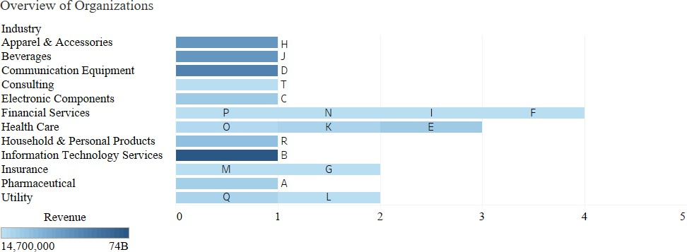

OVERVIEW OF PARTICIPANT ERM PROGRAMS
Variety amongst participants was not solely limited to industry and revenue size. The diverse company mix represented in our study allowed us to see a range of ERM functions, with varying degrees of differences and similarities in terms of structure, reporting levels, and roles. We felt that it was important to inquire about the organizational structure of ERM at the onset of the interview to gain a greater understanding of the relationship between risk and strategy for individual participants and to inform our categorization of organizations' objectives for scenario planning.

Specifically, we collected information related to the number of full-time equivalents devoted to ERM, the title of the ERM leader, the number of reporting levels between the ERM leader and CEO and the role of ERM in scenario planning. Based on the individual responses to these questions, the most common ERM organizational structure and role in scenario planning can be summarized as follows:

The typical ERM program resides within the finance function and is composed of 3 full-time equivalents. The program is helmed by a Chief Risk Officer who reports to the Chief Financial Officer, resulting in one reporting level between the ERM leader and CEO. The ERM program is responsible for leading and facilitating scenario planning activities.

While this summary reflects the most common responses to our questions, each participant's approach to ERM was unique in some way. We found that there was a wide range in the number of FTE's devoted to ERM; several participants only had a single FTE devoted to ERM while one participant had 15 FTEs whose full-time focus was ERM. Similarly, while Chief Risk Officer was the most common title of the ERM Leader, other titles in order of prevalence included Director of Enterprise Risk/ERM Director, Director of Risk and Compliance, VP of Risk Management and Chief Compliance Officer. In terms of organizational structure, most participants’ ERM programs resided under the finance function. Other participants reported having ERM programs which resided either under the strategy function or compliance function.

The responses we received regarding the number of reporting levels and the leader of scenario planning were less varied than the responses to the preceding questions. All but two participants reported having either 1 or 2 levels between the ERM leader and the CEO; one participant reported 4 levels and another reported that the ERM leader reported directly to the CEO. Finally, the vast majority of participants reported that their ERM function leads the scenario planning process within their company. The only other leaders of scenario planning were from one organization whose VP of strategy leads the process and another where the Business Continuity/Resiliency Team leads the process.

SCENARIO PLANNING OBJECTIVES
One of the key questions that we asked participants was, "What are your organization's objectives in conducting scenario planning?". The most common objectives we heard were for support in strategic planning, business continuity planning and risk assessment. Other, less prevalent objectives were for financial forecasting and operational planning purposes. From these responses, we were able to identify three distinct objective categories with which to group the participants:

- Support for strategic planning
- Risk assessment
- Financial Forecasting
Only one participant reported utilizing scenario planning primarily for forecasting future financial performance, however they also indicated that they would like to incorporate the use of scenario planning in strategic decision-making in the future. The rest of the participants fell into either the risk assessment or the support for strategic planning categories. The risk assessment group consists of participants whose primary objective with scenario planning is for the identification, assessment, and mitigation of enterprise risk. We found that a number of participants within this group operated within industries where compliance is an integral component of success or otherwise possessed a culture that emphasized compliance. The support for the strategic planning group consists of participants who not only use scenario planning for risk assessment purposes, but also to identify new strategic opportunities and gaps in current strategic initiatives. The participants within this group tend to have a formal, structured, and holistic approach to scenario planning that is more fully integrated with ERM and the strategic planning process.

Given the fact that many participants exhibited overlap among the three categories as well as the level of subjectivity involved in our grouping, we have plotted the participants across the three categories using a continuum. We used the degree of strategic focus as the scale for the continuum. The scale moves from less strategically focused all the way to fully integrated with strategic planning. This scale made sense for our categories as, generally, there is an increasing level of integration with strategy as you move from utilizing scenario planning for financial forecasting to risk assessment and mitigation to strategic planning.
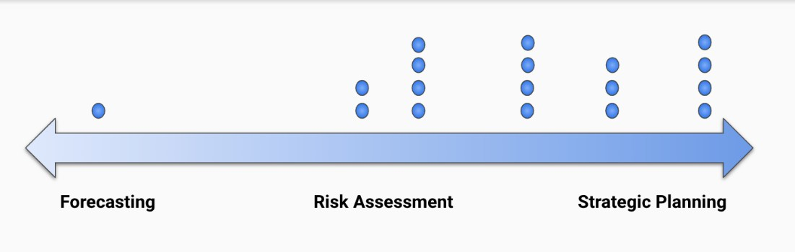

The participants that fall in the middle of the continuum are those whose focus with scenario planning is general risk assessment and analysis rather than as a tool to drive strategic decision making. The participants that are plotted between risk assessment and strategic planning are those

whose process exhibited more of a connection to the strategic planning function but were still more focused on risk mitigation. These participants had more of an "after-the-fact" relationship between strategic planning and scenario planning - scenario planning was conducted after strategic objectives were established as a means of validating reasonableness. For example, one of the participants in this group noted that their use of scenario planning was more reactive in the context of strategic planning, but they want to move towards utilizing scenario planning proactively to identify and take advantage of strategic opportunities. Finally, the participants that fall farthest to the right are those whose primary objective with scenario planning is to drive strategic decision making. These organizations use scenario planning not only for assessing risk, but also in the identification and pursuit of new strategies and opportunities. These organizations utilize scenario planning to support decision-making for both high-level, long-term strategies as well as short-term tactical or operational purposes. Participants in this group generally have well established ERM programs whose connection with strategic planning is clearly articulated and defined.
SCENARIO PLANNING PROCESS

FREQUENCY OF SCENARIO PLANNING ACTIVITIES

Organizations conduct scenario planning either annually alongside strategic planning or risk identification processes, or at other times depending on the objective of the scenario planning activity. The organizations that participated in this case study had varying cycles for conducting scenario planning activities. The predominant practice was to perform scenario
The predominant practice was to perform scenario planning at least annually or biannually.
planning at least annually or biannually. The next common practice was to perform scenario planning on an ad hoc basis.

ROLE OF ERM IN THE PROCESS
Several organizations in our study had the scenario planning process conducted by the ERM team. Even though ERM is leading the process the focus is on creating plausible scenarios that will enable business leaders to make decisions in the face of uncertainty. This allows the ERM lead to act as the facilitator in the sessions and run the scenarios, while allowing the people who will be using the outcome of the process to be drivers of the key inputs for the scenarios. The ERM lead is there to facilitate the conversation to draw out the insights from the senior executives, and other subject matter experts or risk owners who may be affected by the various scenarios. Other organizations whose main objective in developing scenarios is to inform strategic planning had the head of strategy and an ERM lead guide the scenario planning process. One case study participant had a resilience team that led the scenario planning process. The primary purpose for engaging in scenario planning, whether it is risk analysis, strategic planning, or some other purpose, will be a key factor in both determining the role of the ERM function and in determining the key participants in the process. Regardless of who was responsible for running the scenario planning process, it is critical to involve risk owners and leaders from throughout the organization to derive the most value from the process.

SCENARIO PLANNING SESSIONS
In order to gauge what will be most valuable to business leaders in creating the scenarios, organizations use a variety of methods to gather information, including interviews, workshops and planning sessions that include different subject matter experts and thought leaders. Organizations also use the risks that have been identified through their ERM process as the base for their scenarios or as a starting point for discussing potential impacts and alternative responses to particular risk events. There are a few organizations that use brainstorming sessions/workshops to look at important internal and external risk information to help pinpoint which scenarios to use.
Once the most meaningful scenarios have been identified, some organizations develop heat maps for the scenarios to analyze the likelihood and impact of the risks that the scenarios address. For a glimpse into how one organization ranked risks based on likelihood and impact, see Table One below. Then after addressing the likelihood and impact of the risks included in the scenarios, some organizations start conducting workshops. These workshops may include multiple sessions, where the outcomes of scenarios are discussed. The main themes are how likely are these scenarios to happen, what would the potential impact be on the company, and how do organizations mitigate the risks or take advantage of the opportunities. Another type of session that plays out a scenario is a tabletop exercise where organizational leaders walk through the events included in the scenario and the actions the organization will take in response. The main goals of these exercises are to provide practice in implementing response plans and to look for any bottlenecks or gaps in the process.

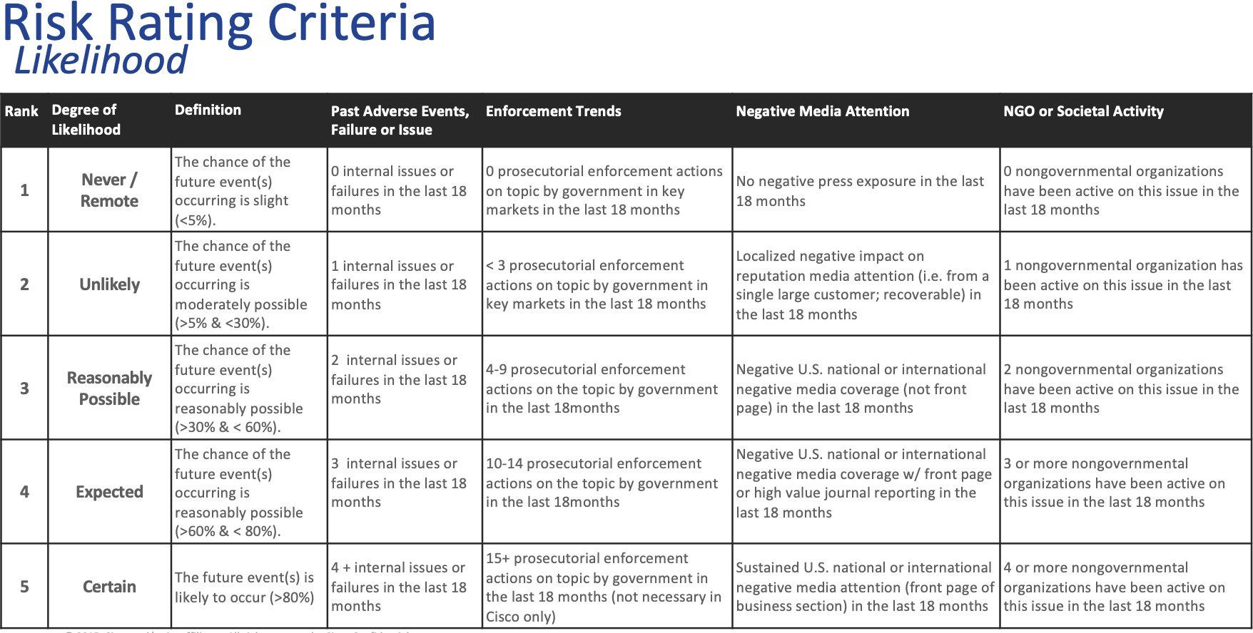
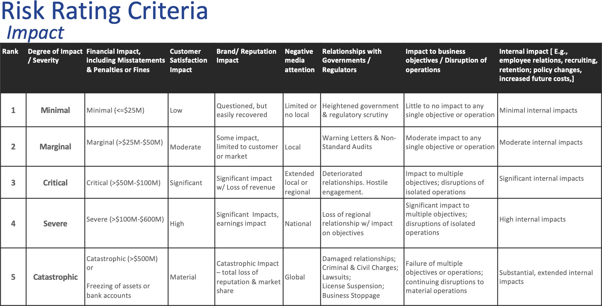
Table One

For some organizations, there is a more ad hoc process where scenarios are identified and evaluated as risk mitigation efforts are considered. One company uses risk drivers and risk scenarios in a risk template, displayed in Table Two, to create the conversation around mitigation strategies. The risk template provides an in-depth view for each important risk and creates the mindset to think about the potential scenarios surrounding these risks. Other organizations use a combination of these different sessions/workshops to develop the scenarios and the ways in which they can mitigate the risk and identify gaps.

Table Two
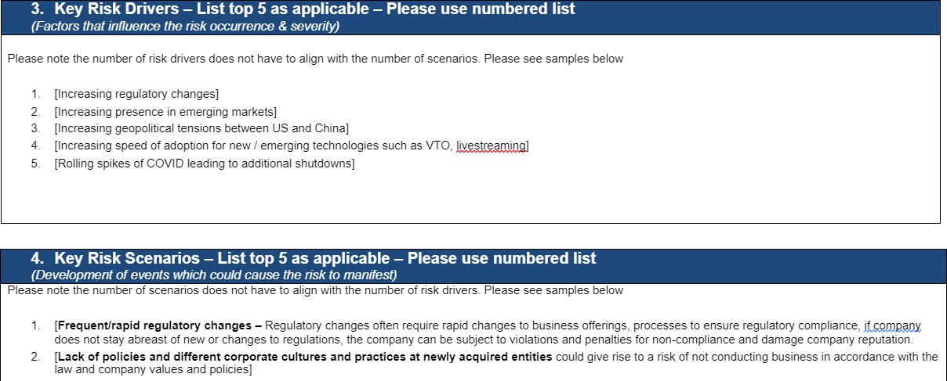

INPUTS, VARIABLES, AND NUMBER OF DIFFERENT SCENARIOS
Nearly every company uses internal and external inputs in their scenario planning process. The internal inputs come from subject matter experts, risk owners, senior management, and/or the ERM staff. Information is gathered through interviews, as mentioned above, or through the use of surveys. On the other hand, external inputs are derived from news sources, outside trends, stakeholder insights, and external benchmarking. The techniques for gathering and organizing important external input information varied across the organizations.
The number of variables is the number of assumptions that will change in the different scenarios, and the assumptions chosen typically to represent the areas where there is the greatest risk or uncertainty. For some organizations three levels of one variable were used, for example representing the minimum, the middle, and the maximum; for other organizations it is more extensive, ranging upwards of sixteen variables. These variables are then combined and changed to create the different scenarios. For example, one organization used two variables. The two variables consist of two identified topics which are then used to create a quadrant of four. Each quadrant represents a different scenario. An example of this quadrant format is shown below in Table Three. Most organizations develop three to four scenarios based on the variables, while one outlier develops 15 scenarios.

Table Three
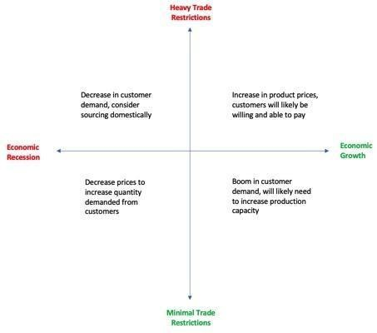

OUTCOMES

SCENARIO PLANNING OUTPUTS

As one company’s ERM leader put it “the output of a scenario planning exercise is a summarized set of risks and opportunities that lead to actionable insights and, where appropriate, owners and next steps.” The quote helps to summarize the desired outputs of scenario planning which were similar across many organizations. Several organizations’ focus was to develop scenario planning processes that produce insights into risks and opportunities that lead to the development of next steps, while identifying potential gaps in response plans. Another principal output of scenario planning is the development of Key Risk Indicators (KRIs). Developing scenarios can help to identify root cause events and related metrics that can then be used as KRIs.

CONTINGENCY PLANNING

The new risks and opportunities that have been identified through the scenario planning process led organizations to think about the potential next steps. The organization’s business leaders assess if there needs to be proactive actions or reactive plans that should be pursued. As a result of the

outputs there may be the creation of contingency plans. The organizations that develop these plans based on the scenarios include actions and recommendations that business leaders can take to mitigate risks. Organizations also look for any gaps or bottlenecks that could be hindering their contingency plans. One organization conducts crisis management exercises that work in tandem with contingency plans. In the crisis management simulation, the organization documents the situation and any lessons learned. From there the company then develops contingency-next steps plans. Similar to the concept of a risk owner, there will be assigned accountability for these contingency plans.

KEY RISK INDICATORS
More than half of the organizations in the case study identified that the scenarios result in the development of KRIs. As one of the ERM leaders stated, “the scenarios result in risk management plans that may be then monitored by KRIs, KPIs (Key Performance Indicators), or OKRs
(Objectives and Key Results) developed by the business.” Developing and playing out the scenarios aids in identifying root causes and intermediate events that can be used as early indicators or KRIs for significant risk events. Those KRIs can then be monitored to identify emerging risks. Leading and lagging indicators can be beneficial to the early identification of risk exposures and can lead
One of the ERM leaders stated, “the scenarios result in risk management plans that may then be monitored by KRIs, KPIs (Key Performance Indicators), or OKRs (Objectives and Key
Results) developed by the business.”
to potential actions to minimize those exposures. A few organizations discussed how these indicators are tied to the contingency plans that were created. KRIs allow for the initiation of activity within the plans, by indicating to management when a level has been reached that would indicate they need to follow through with their plans or potentially consider revisions to the plans.

REVIEW RESULTS

Several organizations have the scenario analysis results reviewed by senior management or the board of directors. For the organizations that have the board of directors review the results, it is usually a high-level analysis rather than a detailed look into the specific scenarios that were run. Some organizations also have councils that review the results. One council that was specifically named by a few organizations was the executive risk council.
CRITICAL SUCCESS FACTORS
There are various factors that contribute to the success of an organization’s scenario planning process. We have identified common factors that would be applicable to any organization looking to connect scenario planning with strategic planning.
The most important factor in achieving a successful scenario planning session is to ensure that the participants involved are engaged. The key here is that the scenarios chosen are realistic. The scenario doesn’t necessarily have to have a high probability of occurrence, but it should be conceivable and should have significant consequences for the organization. Selecting unrealistic

or inconceivable scenarios not only may leave participants disinterested, but it also makes the process less effective and in turn erodes the value of the process. Along with being realistic, scenario planning sessions should include participants who will be affected by the scenario being developed. For example, in a scenario planning discussion related to a potential investment in a new plant, it would make sense to include production managers and finance personnel since the opening of a new plant is more likely to influence their jobs, which will lead them to be more actively engaged in the development of scenarios.
In addition to linking the scenarios to the proper participants, it is also important to have participants be educated on risk and understand the importance of scenario planning. Having employees and participants who are knowledgeable of the value that the process brings generally increases engagement and brings in a greater diversity of thought which can provide benefits beyond the scope of scenario planning. Ways of assisting employees in obtaining an understanding of scenario planning and its value includes having ongoing risk conversations and being transparent as it relates to certain specifics in the scenario planning process. Additionally, the more scenario planning is linked to strategic planning, the easier it becomes for employees to realize the value of the activity.

Organizations have also found enhanced collaboration to be critical to the success of a scenario planning session. One company stated, “If our ERM team is having to talk more than the participants, we’ve done a poor job”. As mentioned earlier, organizations have found value in having participants with different perspectives

One company stated, “if our ERM team is having to talk more than the participants, we’ve done a poor job”.
provide input as it creates an opportunity for the identification of a broader range of risks or issues in any given scenario. To facilitate such collaboration, it is important that there is diversity in participants and the right mix of stakeholders involved in the session. In addition, it is important to consider whether there are any other dynamics that could limit an open discussion, such as whether participants may be hesitant to bring up risks if their direct supervisor is in the room.

IDENTIFIED AREAS OF IMPROVEMENT
With any process, particularly one that is relatively new like scenario planning, there are various opportunities for improvement. Through our interviews, we were able to find a few common areas organizations had targeted for improvement in their scenario planning process.
Among the organizations interviewed, the majority looked to increase the linkage between scenario planning and strategy development. Organizations that conduct scenario planning as a risk mitigation strategy or that focus on just one area of risk may not be realizing all the potential value the process could bring. Organizations are also looking to cover more areas of potential risk and have more cross-functional participation in the process, to avoid taking an approach that could be siloed.
Among the organizations interviewed, the majority looked to increase the linkage between scenario planning and strategy development.
In addition, several organizations are looking to formalize their scenario planning process, having it become a standard part of
the ERM process. Many organizations conduct their scenario planning on an ad hoc basis and are looking to have the process institutionalized and performed regularly to have a more robust proactive approach to manage risks. In changing their process to achieve a more structured approach, organizations are looking to standardize the inputs and outputs of the process to minimize the amount of time spent on planning and allow more time to discuss and debate potential scenarios.

COMMON BARRIERS TO ESTABLISHING SCENARIO PLANNING PROCESS

Many organizations faced barriers when attempting to establish a scenario planning process. The chart below summarizes the number of organizations that indicated they had faced a certain barrier within their organizations:
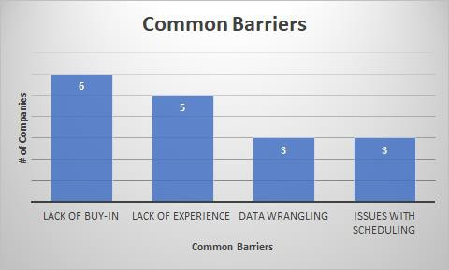

LACK OF BUY-IN
Of all the barriers to establishing a scenario planning process, the lack of buy-in is clearly the most common. In order to get an organization as a whole to buy-in, senior management must understand the value that scenario planning brings. In essence, the value of using this tool is the ability to act proactively in light of various potential risks that can adversely impact a company's strategies or business objectives. Therefore, it is necessary that the purpose of the process and the value it can bring are communicated or demonstrated to senior executives who have knowledge of the company's strategies and objectives. Gaining senior executive buy-in would help to create a supportive tone at the top that can help lead a company in the right direction to utilizing scenario planning effectively.

Even after explaining the value, there may still be people that do not see the benefits it can bring. One reason could be that the associated risk topics do not directly relate to their duties or business functions. Another possible reason is if they have a mentality of "this will never happen to us," which makes scenario planning seem like a waste of time and resources. Another reason may be that executives can get too focused on events happening today or in the immediate past rather than

seeing the benefit of being prepared for potential future scenarios, such as "tail events." In order to get past these ways of thinking, it may be helpful to present examples of how organizations that were prepared for disruptive events that had low probabilities of occurring, such as the COVID pandemic. Companies that had prepared for these sorts of risks were able to adapt to the changing business environment more quickly and as a result faced less disruption, and, in some cases, were able to seize new opportunities. Using an example like this could also shed some light on how the impact of such risk events can affect an organization overall, not just a particular business function. Another practical step to take is gaining an understanding of the organization’s strategic focus and objectives and then tailoring the scenario planning process accordingly.

LACK OF EXPERIENCE
The next most common barrier is lack of experience, which is essentially due to scenario planning being a relatively new strategic planning tool. Having a lack of experience may result in a bit of trial and error before establishing an effective process. There are various ways one can design a scenario planning process, such as the use of workshops or automated tools. Depending on the company, one approach may be better than the next, therefore, it comes down to finding the right fit for a specific company.

When attempting to find the right fit, the number of available resources plays a big factor. For example, if the company does not have the personnel or resources to create an automated program, then it would be better to start on a smaller scale with a simpler process. Additionally, if there is also a lack of buy-in, it could be helpful to start with a simple design, such as workshops or surveys, then update that process over time to gradually build experience and buy-in simultaneously. Updating the process over time would allow for gradual adoption of best practices and the flexibility to shift as the company’s strategic focus may shift.

The main way to combat lack of experience is through education. One participant noted that it is hard to get financial people to think of non-economic events and difficult for operations people to think of economic events and impacts. Scenario planning needs to be a cross-functional process that is understood throughout the organization to truly be effective. Therefore, it would be helpful to employ techniques to educate employees on bigger picture issues affecting the organization’s strategic objectives to broaden the focus beyond individual departments.

DATA WRANGLING
The third most common barrier was data wrangling, which deals with the challenges of handling large volumes of data and cleaning and normalizing the data. This is an extremely important step in the scenario planning process as the data will eventually be used as inputs. If the inputs are not cleaned and normalized, then the whole scenario planning process could be compromised. Further, if the scenarios associated with unreliable data are used in decision-making, sub-optimal performance is likely to result.

There are also potential pitfalls with handling big data which requires special attention to cleansing and normalizing to facilitate the extraction of pertinent data. To do this, creating an automated process could improve efficiency by filtering data and facilitating the risk identification and input processes. However, it should be noted that if a company does not already have strong in-house technical expertise, this may not be a cost-effective option. Another reason an automated process

would be helpful is the fact that scenario planning takes a lot of learning and practice, which requires significant resources. One company stated that a “centralized team can only perform a limited number of assessments” and “decentralizing requires upskilling across diverse populations.” This reasoning makes it easy to see the benefits of constructing an automated process. It can allow for less personnel and training to be involved in the process, which will lead to greater efficiency. The fact that the scenarios would be routinely updated using automation could lead to more frequent and more useful outputs as well.

SCHEDULING ISSUES
The final common barrier was found to be issues with scheduling. The main problem here is being able to find time between multiple participants, which can be solved in part by keeping groups smaller. It was commonly found that most organizations have about three people participating in any given scenario planning session. Additionally, for organizations that do not have an automated process, conversations with risk owners and subject matter experts across the organization are the most important step of the process. Again, education around the value that a scenario planning process can bring will help to have the most people wanting and willing to be involved.
TECHNOLOGIES

Organizations use technology to varying degrees in carrying out the scenario planning process. While some simply use the Microsoft Office suite to develop and run scenarios, others use more sophisticated applications. It may be helpful to incorporate some of these technologies depending on how mature a company or its scenario planning process is. On the other hand, some of these may not be applicable to some organizations as they require different levels of expertise and have varied costs.

EXCEL, POWER BI, AND TABLEAU

The first technologies are Excel, Power BI, and Tableau. They are all grouped together because they are all business intelligence and data analytics tools. These tools allow users to create databases through the collection of data sets from many sources. Some data analytics tools require a data scientist; however, these are simple enough that anyone can learn how to use them. Some of their core features that apply to scenario planning include data mining, data processing, and data transformation.
The first of the three technologies to be discussed is Excel and it is the simplest of all of them. It is a Microsoft Office application with many useful functions to organize, format, calculate, and graph data. It is supported by decades of development, such as the increasing amount of data it can hold. It is now able to hold a little over one million rows of data, which is still less than Power BI and Tableau’s ability to handle large sets of data. Therefore, Excel should be used more for simple analysis rather than dealing with big data. On the other hand, it is a much more affordable option than Tableau as it is part of the Microsoft Office suite.
Next is another Microsoft Office application, Power BI. This application is a popular business intelligence platform as its user interface, Microsoft Office, is one that many people are already

accustomed to and find easy to use. It is mainly used to manipulate data to generate reports, visualizations, and dashboards. It is also cloud-based, which allows multiple users to connect to, visualize, and analyze data. One function that stood out was Power Q&A, which is a natural question and answering engine used for data analysis. In essence, once there is a model built within Power BI, a user is able to ask a question using their own language (e.g., number of customers by state). Afterwards, it will give an AI-powered answer in the form of a visual. This is an extremely simple process and an economical option as it is part of Microsoft Office.

The last technology in this subsection is Tableau, which is a data visualization and analytics platform. It also allows for business intelligence by being able to generate shareable reports based on information from the company. The query language used is VizQL, which translates drag-and-drop dashboard and visualization components into useful insights in an effective way. However, the platform does not support advanced SQL queries for those organizations with data scientists. Another key finding was that Tableau allows access to more data sources than Power BI. The main reason why Tableau is so popular is because it is the best for creating visualizations and can handle larger volumes of data quicker than other platforms, such as the Microsoft applications. On the other hand, Tableau will be more expensive than the other options.

ORACLE: CRYSTAL BALL

Crystal Ball is an Oracle product that is used in Excel as an add-on and is a very powerful tool for risk analysis. In order to combat the inherent risk that comes with uncertainty, Crystal Ball automatically calculates thousands of “what-if” scenarios in a three-step process that Oracle lays out:
- For every assumption cell, a random number is generated according to a range that is predefined by a user and recorded in the spreadsheet.
- The spreadsheet is automatically recalculated.
- Values from each forecast cell are added to the forecast chart.

While this is being done, the program is also keeping track of the inputs and results of the calculations as individual scenarios. Through analyzing these scenarios, one can view the range of possible outcomes, the probability of them occurring, and which inputs have the largest impact on variations. In addition, Crystal Ball allows for visualizations to be utilized in order to share insights on risk. Overall, the main benefits of using this program are that it is an easy-to-use tool that automatically generates possible scenarios and visualizations with a push of a button.

ORACLE: HYPERION
Another Oracle program used in some organizations was Hyperion, which includes a suite of software products. It is a web-based application for global financial consolidation, reporting, and analysis. One of the key features related to these functions is the ability to integrate and manage a firm’s goals and strategies along with solutions to achieving them. It also allows for quick access

to data with a goal to improve a company’s business decision-making and business intelligence. The main benefits include accessibility on cloud networks, ability to understand financial and accounting needs, and high security around data.

PLATFORMS FOR DATA WRANGLING AND RISK IDENTIFICATION
There were a few platforms found within the study that deal with data wrangling and the risk identification process. The first one was Python where a data scientist is going in to clean and normalize data through coding. Another was an internally made platform that included capabilities to help identify risk drivers and then generate a spider web of connections based on likelihood, impact, and velocity. It also allowed manual inputting of data from other personnel within the organization to get insights from various levels. Once risks are identified and compared, users can then manipulate this data to see the potential impacts of risks. Finally, MG-ALFA was another tool used to indicate risks for insurance companies. One of its key functions is application lifecycle management (ALM), which makes projections based on financial data, cloud computing, and modeling for insurance liabilities and assets.

THINK TANK
Think tank is a platform used to get engagement and collaboration within a company and with outside stakeholders as well. This is a tool that can help in coming up with inputs for scenarios; however, it does not include any option to run scenarios. By having greater collaboration, a company can gain more insights and perspectives, leading to better cohesiveness and decision-making. One of the common barriers discussed earlier was the ability to get the right people in the right room at the right time. This platform could be helpful with this issue by getting more involvement when trying to identify risks and other useful information for creating scenarios. Also, Think Tank is a cloud platform that can handle big data.

MIRO
Miro is another collaboration tool that can get personnel within a firm talking about risks. One of the key features of Miro is that it has an infinite canvas for the whiteboard where users can organize their information or workflow. Additionally, there can be both synchronous and asynchronous collaboration as people can go in and out of the whiteboard to add and gain an understanding of important information. Once again, this is a great tool to get a cross-functional perspective for scenario planning when it is hard to find time to do so.
BEST PRACTICES AND CONCLUSION
Scenario Planning varied across all the organizations. Each organization focused on what would be the most valuable outputs from the scenarios. Since each organization developed a unique process that fit their needs and objectives, it is impossible to describe a standardized scenario planning process that could apply to all organizations. However, there were some key themes and best practices that came up repeatedly in the study.
The first best practice observed is that scenario planning should have support and buy-in from the top. Senior executives should understand the value and benefits of performing scenario planning and champion its use within the organization. It is important that all key stakeholders within the

organization understand the potential value of scenario planning and hold themselves accountable to action plans formed from the results of scenario planning. In this way, the scenario planning exercise results in tangible action that demonstrates value rather than potentially becoming just another compliance activity to check-off. The communication of scenario planning’s value proposition across the organization should emphasize that given scenarios can provide actionable insight and strategic support for a wide range of applications within the organization.
In addition, the ERM function should be careful to maintain a facilitator role in the scenario planning process as the participants should be the ones talking and developing the scenarios during the sessions. As one ERM leader said, “it's our job to use our expertise to help you guys talk about risk…the frontlines own the risk." To ensure that the scenario planning session is effective, it is additionally important to ensure the right participants are involved and that the scenarios are realistic and pertinent to the roles of the participants.
For an ERM program to be run efficiently and effectively, information must be able to reach the decision-makers of an organization quickly and smoothly. This is particularly important with activities such as scenario planning that can result in the identification of activities to both manage risk and seize opportunities. To improve the information flow and keep the focus on the most significant strategic risks, there should be as few reporting levels between the ERM leader and decision-makers as possible. Fewer levels enable a more direct reporting channel that can speed up the flow of risk information to key decision-makers and emphasize the importance of ERM within the organization.
One key theme that ERM Leaders in the study mentioned repeatedly was the benefit of conducting scenario planning on a more structured basis. Organizations found a benefit in performing scenario planning at least annually in tandem with updating risk inventories and in conjunction with the refreshment of strategic plans. A few organizations mentioned a benefit in performing scenario planning bi-annually or even quarterly, particularly when the risk landscape is changing rapidly. Another key theme tied to structured scenario planning was to ensure that scenario planning is being used to identify strategic opportunities, as well as risks. For example, some organizations proactively used scenario planning to evaluate and set long term strategic plans, in addition to using it to make decisions around shorter term, tactical plans. By expanding the scope to consider opportunities, scenario planning becomes a more useful tool in the strategic planning process and is more likely to be seen as value-adding across the organization.
We hope that you find the information contained in this case helpful in evaluating and improving the scenario planning process used at your organization.

APPENDICES:
SAMPLE INTERVIEW QUESTIONS, ORGANIZATIONAL STRUCTURES, AND AUTHOR BIOGRAPHIES

APPENDIX A: SAMPLE INTERVIEW QUESTIONS

Company and Organizational Information:
- Confirm the following census data: Industry, total revenue, market capitalization, total assets.
- What is the organizational structure of the ERM function, and the individuals involved?
  - How many full-time equivalents are devoted to ERM?
  - What is the title of the ERM lead?
  - Where does ERM report in the organization? (Ex: through CFO organization, legal, etc.)
  - How many reporting levels are there between the CEO and ERM leader?
  - What is the relationship between the ERM function and the strategic planning function at your organization?
  - What other departments or functions help leverage the ERM Process

Scenario Planning Process Overall:
- What are your organization’s objectives in conducting scenario planning?
- Do you conduct workshops or sessions to either develop or discuss the results of your scenario planning process?
- Can you provide an overview of your organization’s scenario planning process?
- What is the connection between scenario planning and strategic objectives?
- How long is a typical scenario planning meeting/session?
- What technology do you use in running the scenarios?
- What is the role of the ERM function in that process? (who does what)
- Who (organizationally) leads the scenario planning process?
- Who else (organizationally) is involved? How many individuals participate and what are their roles in the organization?
- What is senior management’s level of involvement with scenario planning?
- How often does the company engage in scenario planning?
- Annually as part of the regular planning cycle
- More often, for example to forecast year end results.
- Another schedule (i.e., ad hoc, project based)?
- Do the scenarios result in the development of any KRI’s or other indicators?

Development of Scenarios:
- Inputs to Scenario
- Source – one or many; internal or external or combination??
- Number of variables (assumptions that change)
- Key variables?
- Number of different scenarios (combinations of variables), for example, some have base case, plus one upside and one downside scenario. Do you have a method for ranking each scenario based on likelihood and impact?
- What is the output from the scenario planning process?

- Full set of financials for each scenario, or just some?
- Operational/output results?
- Recommendations for identified risks/opportunities?
- New strategic insights?
- What modeling approaches/techniques are used for scenario planning?
- How are the results of the scenarios used?
- Does the organization develop contingency plans or other “next steps” for certain scenarios?
- How do you ensure accountability and action following scenario planning?
- Who (organizationally) receives/reviews the scenario results? Senior management? Board of Directors?

Effectiveness and Evolution of Scenario Planning Process
- When did you start using scenario planning?
- How did you establish your scenario planning process?
- How has the process changed over the years?
- What barriers or obstacles did you face in establishing a scenario planning function?
- How beneficial do you find scenario planning in the context of the overall success of your business?
- Has your scenario planning process changed in any way as a result of COVID?
- Could you think of examples outside of COVID where a disruptive event has changed your scenario planning process?
- What works well in your scenario planning process?
a. What scenario planning efforts were successful and what efforts were not? Why were they unsuccessful?
- Is there anything you’d like to improve or plan to improve in your scenario planning process going forward? If so, what?
- In what ways have new technologies/applications helped with the process of scenario planning?

Final Question
- Is there anything else you’d like to add about scenario planning?

APPENDIX B: ORGANIZATIONAL STRUCTURE

Example | Industry | Title of ERM Lead | Reporting Relationship | Number of Levels
A | Information Technology Services | CRO | Reports to the Treasure in the CFO's organization. | 2
B | Electronic Components | Director of Enterprise Risk | Reports to the Finance Organization. | 4
C | Communication Equipment | CCO | Reports to the CFO. | 1
D | Health Care | VP of Risk Management | Reports through the compliance organization. | 2
E | Financial Services | ERM Senior Manager | Reports through the legal department. | 1
F | Insurance | CRO | Reports to the Board's risk committee. | 1
G | Apparel & Accessories | Senior Director Risk | Reports to the VP of Global Risk Management. | 2
H | Financial Services | CRO | Reports directly to the CEO. | 0
I | Beverages | Director of ERM | Reports to the Controller. | 1
J | Health Care | Program Manager | Reports to the senior VP of integration who then reports to the COO. | 2
K | Utility | Director of Risk and Compliance | Reports to the VP then to the CCO. | 2
L | Insurance | CRO | Reports directly to the CEO | 1
M | Financial Services | Senior Director of ERM | Reports to the CRO. | 1
N | Health Care | ERM Director | Reports to the Chief Strategy Officer. | 1
O | Financial Services | VP of Enterprise Risk | Reports to the Chief Admin/ legal officer. | 1
P | Utility | CRO | Reports to the CFO. | 1
Q | Household & Personal Products | CRO | Reports to the Treasurer who then reports to the CFO | 2

APPENDIX C: ABOUT THE AUTHORS

NC State ERM Practicum Team Biographies
